Does Team Success Mean Higher Attendance

1. **Introduction**

Nobody who likes sports likes to lose. Nobody who watches sports likes to watch their favorite team lose. But would people actually still pay money to come watch their hometown teams even if they do not win very often? This project will investigate the relationship between a team’s wins and their average home attendance. By viewing the relationship between wins and home average attendance, we can see if people will come watch their hometown teams live regardless of their status within the league. The better teams in the NBA would be expected to bring in larger crowds than the lesser teams in the NBA.

This project is not only interesting to the casual NBA fan, but also could be vital information for NBA team owners and general managers. The goal of NBA team owners is to generate profit while the goal of NBA team executives is to build and form the best teams they can. If winning more games is shown to draw large crowds, team owners and executives would be inclined to take a look. NBA team owners want their teams to bring in as much revenue as possible and if data shows that putting together better teams correlate to bigger crowds, then team owners would be motivated to focus on forming and building good teams. This information could be also be used to determine ticket prices for teams and attempt to maximize revenue from attendance. Team executives could also use this data to their advantage by securing their job by putting forth teams that win more games. It would be in their best interest to satisfy the team owners with their ability to build and create teams that win.

**2. Dataset**

The dataset used in this project is a ranking of the teams that brought in the highest average home attendance throughout a fifteen year period starting from the 2000-2001 season to the 2015-2016 season. The teams are ranked from 1-30 in order of their average home attendance. Other columns included the team’s total home attendance for the season and also away game attendance as well. A separate dataset with each team’s wins during the respective season was created and added to the original dataset in order to compare the relationship between wins and average home attendance. The dataset consisted of 476 rows with the first row being the team that brought in the highest average home attendance during the 2015-2016 season and ending with the team that brought in the lowest average home attendance during the 2000-2001 season. Next to each team was a column indicating their win total for the season. Both datasets were rather clean and did not require much wrangling and cleaning. Although there were some missing values in some columns, there were no missing values in the columns that would be used in this project so they were left alone. The only modifications made to the datasets was merging the two datasets and changing the order of the columns for easier viewing.

**3.Analysis**

By just quickly browsing through the data, it would seem that wins do not affect the average home attendance. My initial hypothesis was that a team’s wins would not greatly affect the average home attendance. At first glance, some teams that did not win many games were amongst the leaders for average home attendance throughout the league. I would have expected to see the top teams in the league based on their wins to be attracting the biggest home audiences on average but that did not seem to be the case at first glance. The 2015-2016 Lakers won only 17 games during the season, one of the worst records in the league, and they still managed to rank in the 11th slot for highest average home attendance. The 17-win Lakers beat out the 67-win Spurs, the 48-win Celtics, and the 55-win Thunder. Alternatively, there are also cases of good teams who seem to struggle to attract people to games. During the 2015-2016 season, the Hawks won a very respectable 48 games during the season but only ranked in the 22nd in the league in terms of average home attendance, behind the 23-win Suns and the 33-win Kings.

An introductory plot of just investigating the general attendance trends in the NBA throughout this 15-year period show that attendance league wide seem to be increasing and that the average of league wide attendance seems to be increasing as well. 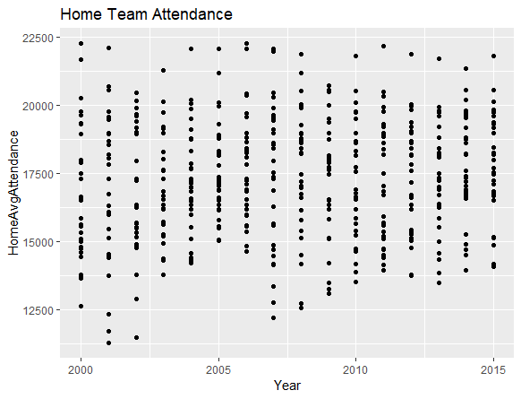

By looking at the graph above, we can see that as the years have passed, the lowest average home attendance for the year has steadily increased. Although the highest average home attendance did not increase, it seems that the general attendance numbers in the middle have also increased. As the graph shows, there are some teams that bring in an average home attendance that is substantially above the league average while some teams attract an average home attendance that is significantly below the league average. In a league with 30 different teams, different cities, and different fan bases, there is bound to be disparity amongst the home attendance of teams. Some years will have a greater disparity than other years. The year with the biggest gap in average home attendance between the most popular team and least popular team was in the year 2001 with a staggering margin of 10,821 people on average. The 2014-2015 season had the smallest gap with a margin of 7,302.

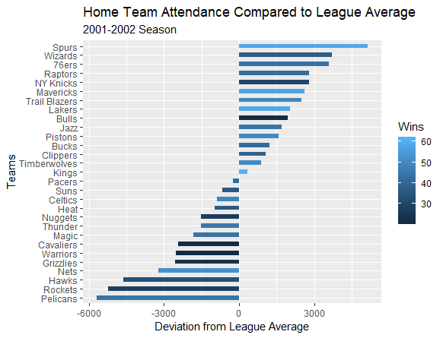

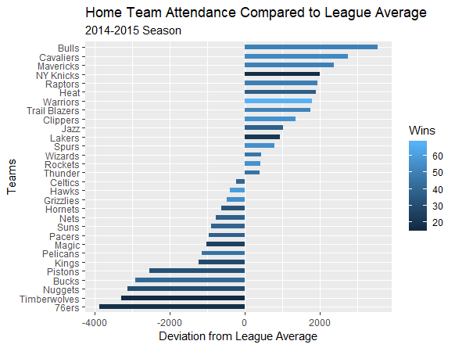

By producing scatterplots of the data in an attempt to represent the relationship between wins and average home attendance, a relationship is present. By plotting all the wins over the 15-year period as the independent variable against the average home attendance over the 15-year period as the dependent variable, a positive relationship is seen on the graph. The scatterplot shows the relationship between wins and average home attendance. As seen below, besides a few anomalies, as wins increase it appears average home attendance increases as well. The correlation between wins and average home attendance is .47. Although it may not be a particularly strong relationship there still seems to be a visible relationship.

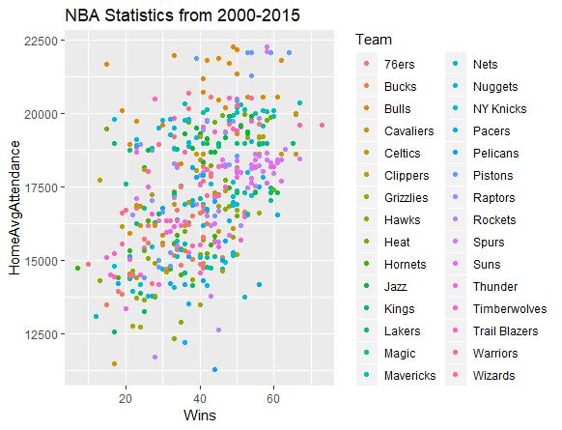

The positive relationship between wins and average home attendance is also apparent if we take a look at specific years and some years show more of a positive relationship than others. The graph below shows the data of the 30 teams during the 2015-2016 season. The correlation

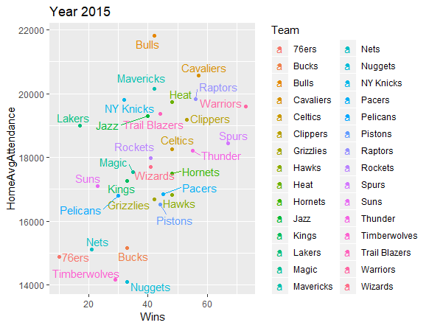

After investigating the trends for each specific year, the range in correlation was quite wide. The lowest correlation was in the year 2003 with a correlation of .28 and the highest correlation was in the year 2006 with a correlation of .69. Both graphs are shown below.

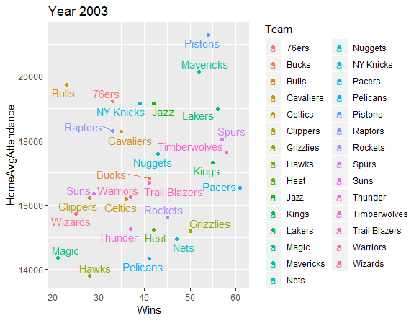

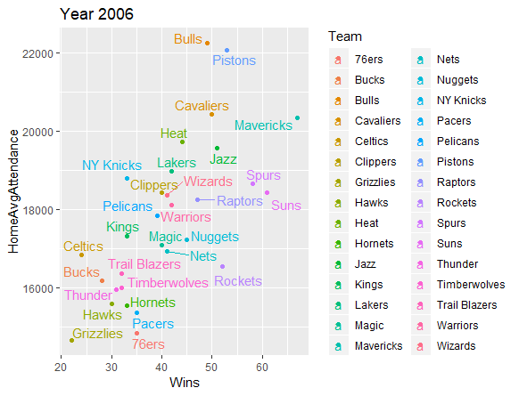

By exploring the relationship between wins and average home attendance for each specific year, we can see that some years showed strong relationships while some years showed very little relation. The same can be said when exploring the relationship of wins and average home attendance for each team in the NBA. The spectrum of specific team correlation is quite diverse. The Dallas Mavericks came in with a correlation of -.06 in relation to their wins and average home attendance. As seen in their graph, it appears as though regardless of their wins, the Mavericks attract a consistent amount of people. With the 2000-2001 season being the only anomaly, every single year, the Mavericks have ranked in the upper echelon of the league in garnering the highest average home attendances. On the other hand, the Detroit Pistons had the strongest correlation value between wins and average home attendance was .83. As seen in the graph below, there is a stark contrast in average attendance when comparing the seasons the Pistons won many games as opposed to season where they did not win many games.

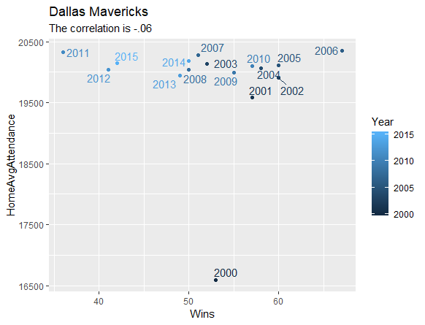

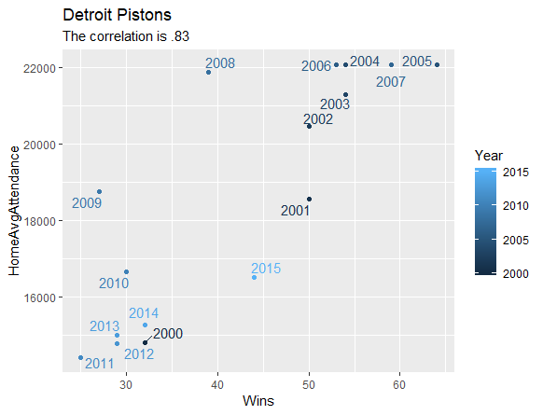

**4. Discussion**

Based off the results of the analysis of the data, it can be concluded that there does in fact seem to be a relationship between wins and average home attendance. There were some years where the relationship was less evident but as of the most recent five seasons, the correlation has hovered around .5. The correlation between wins and average home attendance fluctuates more when looking at specific teams. While some teams like the Detroit Pistons, Memphis Grizzlies, and Denver Nuggets show very strong correlations between wins and average home attendance, other teams such as the New York Knicks, Dallas Mavericks, and the New Orleans Pelicans show virtually no relation or even negative trends.

By looking at the overall trends year by year, there seems to be a definite correlation between winning more games and bringing in a larger average attendance. Diving deeper into the dataset and looking at each individual team’s trends over the 15-year period, some interesting points can be made. Most teams show a moderate to strong relationship between wins and average home attendance. As mentioned before, the Pistons, Grizzlies, and the Nuggets showed the strongest correlations throughout the league. All three find themselves in similar situations in that their graphs seem to visualize that the more games they win, the higher their average home attendance. This can be hopeful news especially for the Detroit Pistons who are struggling as of the recent years but enjoyed one of the largest average home attendances in the entire league during the early 2000’s when they were winning many games.

While most teams experienced mostly positive correlations between wins and average home attendance, some teams posted correlations close to zero or even went negative. The New York Knicks, Dallas Mavericks, and New Orleans Pelicans posted the three lowest correlations in the league from the 2000-2001 season to the 2015-2016 seasons. Although these teams posted similar correlations, the implications are very different. While the Knicks consistently find themselves amongst the league leaders in average home attendance, their wins have fluctuated greatly during the time span. More interestingly, the Knicks had a higher average home attendance in their 23-win 2007 season than their 54-win 2012 season. The trend of the Knicks shows that regardless of their wins, they are capable of attracting a substantial amount of people to their arena. One potential reason for this could be the fact that the Knicks have the privilege of playing in New York City, which is known as the “Mecca of Basketball” and people show support for their hometown team regardless. The Dallas Mavericks find themselves in a similar situation as the Knicks in that their average home attendance is fairly consistent despite the fluctuation in their wins as well. Although their spectrum of wins is not as wide as the Knicks, the Mavs are consistently amongst the top teams in terms of average home attendance. The New Orleans Pelicans on the other hand, find themselves consistently in the lower half of league attendance year after year. Unlike other teams who find sometimes find themselves in the lower half of the league in average home attendance but have a strong positive relationship between wins and average home attendance, the Pelicans show virtually no relationship. This could possibly mean that no matter how good the team is and how many games they win, their average home attendance would not increase. Another team with a surprisingly low correlation between wins and average home attendance would be the San Antonio Spurs. The Spurs have consistently placed within the upper echelon of teams in terms of attendance and also wins throughout this 15-year span. While many teams go through times of success and struggle, the Spurs have been a model of consistency during this duration and their minimal variance could explain their miniscule correlation.

Could there be another factor that draws in a larger attendance than just wins? Could a single iconic player or a group of electric players have an impact on attendance? It certainly appears so in the case of the Los Angeles Clippers. The Clippers’ saw a dramatic increase in their average attendance during the 2011-2012 season and continued to grow in the following years. Coincidentally, that season was the first season of “Lob City”, symbolizing the entertaining style of basketball played by the Clippers after new acquisitions of players. Of course, the number of wins also grew so the two variables could have worked together to cause the substantial increase in attendance. Interestingly, the Washington Wizards also experienced a similar effect except the addition of a new player did not translate to more wins. The Wizards saw a boon in their attendance during the 2001 and 2002 seasons even though they did not win many games. Those two seasons just happen to be the two seasons in which arguably basketball’s most iconic player, Michael Jordan, suited up for the Wizards. The two seasons Michael Jordan played for the Wizards saw almost an additional 20,000 fans per home game than their next highest season.

Looking at the league as a whole, there appears to be a general relationship between wins and home attendance. But as this research revealed, each specific team has its own relationship. It is useful for the NBA to know that as a whole, the more teams win the more people show up and teams will have to view their specific correlations and plan accordingly. Some teams who have a strong relationship but find themselves with underwhelming attendance can take this data and attempt to win more games since they know that more wins will eventually lead to more attendance. Other teams have a benefit and luxury of knowing that their average attendance is relatively consistent despite fluctuating successful seasons. Some other teams may struggle to bring in an average attendance despite winning more than average and may consider acquiring a very popular player in order to boost attendance.

**5. Future Considerations**

One possible variable to add to this research would be to calculate and add a column depicting the percentage of seats the teams fill up. Every team plays in a different arena with a varying amount of seats so it would be interesting to see the data on how many teams actually fill up their stadiums or if some teams fail to do so on a consistent basis. By adding that information to this dataset, we could compare the percentage in which teams fill up their stadium. By looking at a team’s percentage of filling the arena, it could put every team on a level playing field. For example, a team with a bigger arena would be able to bring in bigger crowds than a team with a smaller arena but if the team with a small arena consistently sells every seat while the team with the bigger arena fails to sell out every seat, then the case could be made that the team playing in the smaller arena is actually performing better than the team playing in the bigger arena. It would be interesting to see if there was a change in the rankings of team if they were to be compared by the percentage in which they fill their stadiums as opposed to just looking at the number. This could potentially be a further investigation for this project and it would be something to look into.

Another potential extension for this project would be to explore any other variables that could influence a team’s average home attendance such as having a marquee player. That idea was briefly explored before but not based on any circumstantial data, so some additional research would be required. Data tracking the NBA’s most popular players and seeing if their presence has any visible effect on attendance would be another interesting field to explore.